Efficient Mobile Cloud Computing through Computation Offloading
ABSTRACT
Mobile Cloud Computing (MCC) has been introduced to be a prospective technology with the explosive growth of mobile applications and evolving cloud computing concept. MCC is the integration of cloud computing in the mobile technology environment. It refers to an infrastructure where both data processing and data storage is taken away from the mobile device into the cloud. The purpose is to overcome the obstacles of mobile computing related to battery life, storage, bandwidth, heterogeneity, and security. To throw the computational burden of mobile devices the execution offloading technique is suggested that migrates process between machines. In execution offloading the decision of where the code regions to be executed is taken statically or dynamically based on the execution time and process state. The success of MCC depends on the efficient offloading technique that meets the requirements of energy consumption. In this paper, first, we define the MCC and the benefits of offloading to save energy and execution time. Then we presented different offloading techniques in the wireless heterogeneous network to make proper utilization of cloud. We demonstrated that when the models to be used and how it will fasten and empower the applications. Finally, we suggested rich application models for MCC that will enhance the future mobile industry.
Existing System
According to the International Data Corporation (IDC) Worldwide Quarterly Mobile Phone Tracker, it is estimated that 982 million smartphones will be conveyed worldwide by 2015 [2]. However, it is still challenging to develop extremely sophisticated applications on mobile devices because of the resource constraints like finite battery energy, low CPU speed, insufficient storage space, low network bandwidth and inadequate sensing capacities [3]. Besides, to minimize device fragmentation [4], virtually all smartphones adopt cross-platform runtime environments, such as Java ME, .NET CF, and Android to develop and run applications. So the challenges in mobility management, quality of service (QoS) insurance, energy management, and security issues come to the front
Disadvantages
- Low CPU speed,
- Insufficient storage space, low network bandwidth and inadequate sensing capacities
Proposed System
It allows users to use infrastructure (e.g. servers, networks, and storages), platforms (e.g. middleware services and operating systems), and software (e.g. application programs) provided by cloud providers (e.g. Google, Amazon, and Sales force) at on-demand computing, utility computing or pay as you go computing concept. The CC concept is based on offloading computation to remote resources providers over the internet. As CC enables users to elastically utilize resources in an on-demand fashion, mobile applications can be rapidly delivered with minimum effort and more computing power. For a large number of mobile application users, CC can provide a variety of services. This introduces Mobile Cloud Computing (MCC) as the integration of CC into a mobile computing environment.
Advantages
- The CC concept is based on offloading computation to remote resources providers over the internet.
- Minimum effort and more computing power. For a large number of mobile application users, CC can provide a variety of services.
- The mobile cloud can change the technology trend and bring a huge improvement in our daily lives by solving many real-life problems.
System Architecture
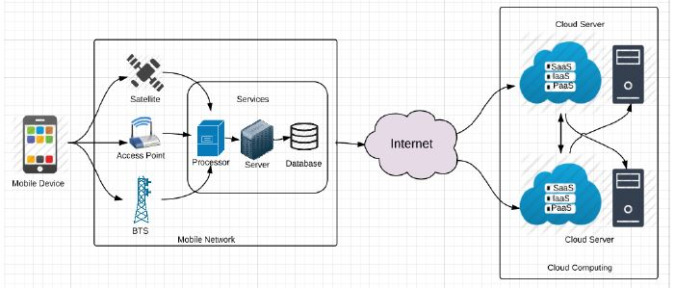
Fig. Cloud computing architecture.
Hardware Requirements:

Processor - Pentium –IV
- Speed - 1.1 GHz
- Ram - 256 MB
- Hard Disk - 20 GB
- Key Board - Standard Windows Keyboard
- Mouse - Two or Three Button Mouse
- Monitor - SVGA
Software Requirements:
- Operating System - Windows XP
- Coding Language - java

